Multi-Component Composite Solids

Definition
# Source: AI Source: Provided by: [Data Path: Persons Table -> ID Column: 1, Name_En Column: Motasem Essam] -> From: [ChatGPT] on [7/25/2026]
Multi-Component Composite Solids are composite three-dimensional objects formed by combining three or more solid components into one overall geometric structure.
The components may have identical or different shapes, dimensions, and orientations. They can be arranged through stacking, end-to-end connections, side attachments, coaxial alignment, nested arrangements, or combinations of multiple arrangements.
Unlike composite solids consisting of only two components, multi-component composite solids contain at least three individual solid components.
Simple Definition: Multi-component composite solids are three-dimensional shapes formed by combining three or more solid geometric components.

Geometric Representation
# Source: AI Source: Provided by: [Data Path: Persons Table -> ID Column: 1, Name_En Column: Motasem Essam] -> From: [ChatGPT] on [7/25/2026]
A multi-component composite solid may contain:
- Three or more identical solid components.
- Several different solid shapes combined together.
- Multiple components arranged around a central component.
- Components connected through different faces or surfaces.
- Multiple layers or sections forming one complete structure.
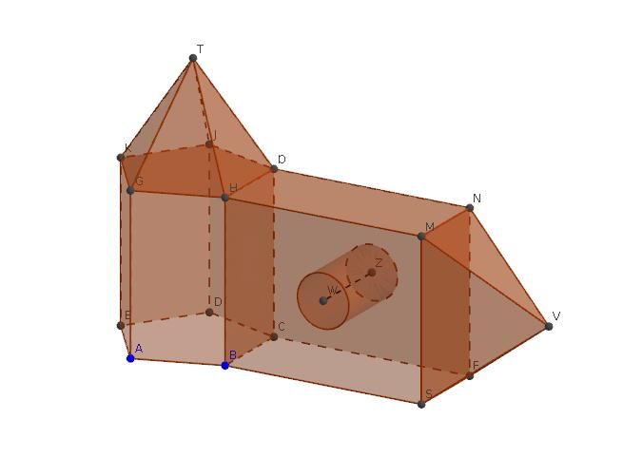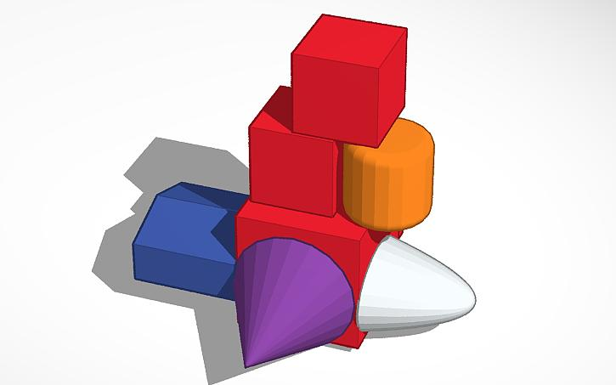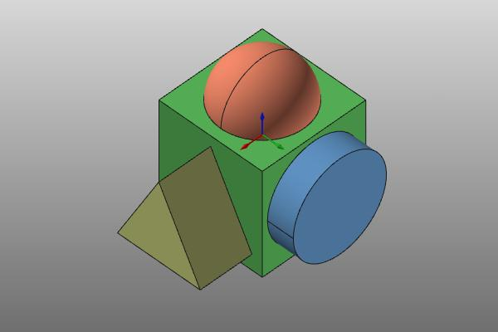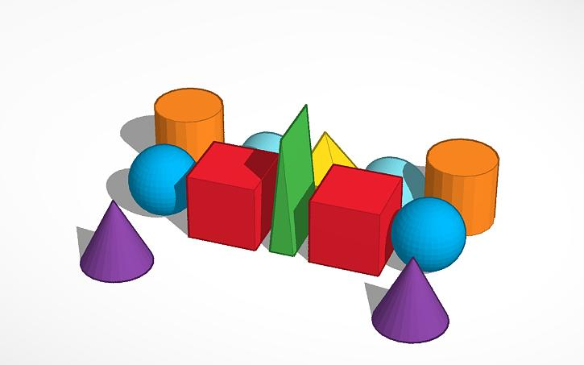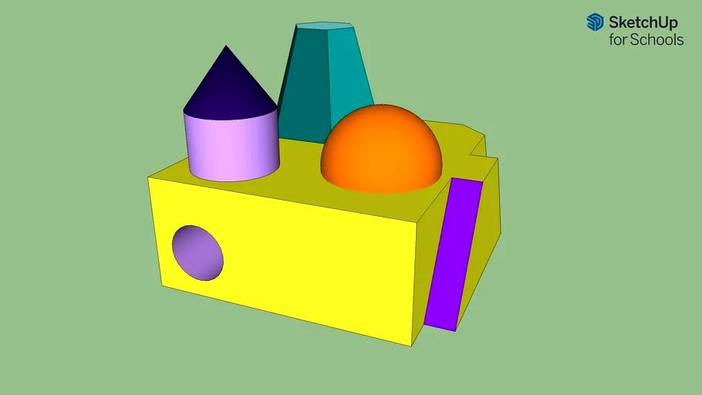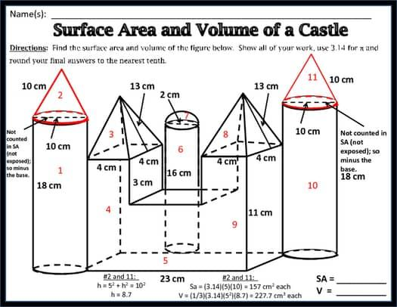

Main Classification

Types of Multi-Component Composite Solids
# Source: AI Source: Provided by: [Data Path: Persons Table -> ID Column: 1, Name_En Column: Motasem Essam] -> From: [ChatGPT] on [7/25/2026]

Prism-Based Multi-Component Composite Solids
# Source: AI Source: Provided by: [Data Path: Persons Table -> ID Column: 1, Name_En Column: Motasem Essam] -> From: [ChatGPT] on [7/25/2026]
Formed by combining three or more prism components.
Examples:
- Multiple rectangular prisms arranged in layers.
- Several triangular prisms connected together.
- Different polygonal prisms combined into one structure.
- Mixed-size prisms arranged in stepped configurations.
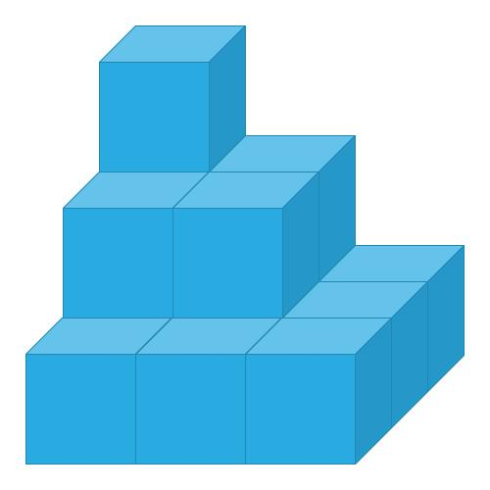

Cylinder-Based Multi-Component Composite Solids
# Source: AI Source: Provided by: [Data Path: Persons Table -> ID Column: 1, Name_En Column: Motasem Essam] -> From: [ChatGPT] on [7/25/2026]
Formed by combining three or more cylindrical components.
Examples:
- Multiple cylinders stacked vertically.
- Several cylinders arranged side-by-side.
- Coaxial cylinders with different radii.
- Multiple cylindrical sections connected through their circular bases.
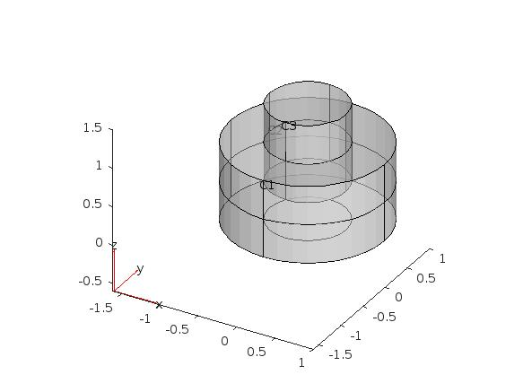

Cone-Based Multi-Component Composite Solids
# Source: AI Source: Provided by: [Data Path: Persons Table -> ID Column: 1, Name_En Column: Motasem Essam] -> From: [ChatGPT] on [7/25/2026]
Formed by combining three or more conical components.
Examples:
- Multiple cones arranged around a central axis.
- Several cones connected base-to-base.
- Cones attached to cylindrical components.
- Mixed-size cones arranged in layers.
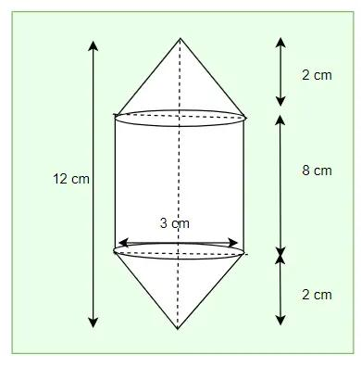

Pyramid-Based Multi-Component Composite Solids
# Source: AI Source: Provided by: [Data Path: Persons Table -> ID Column: 1, Name_En Column: Motasem Essam] -> From: [ChatGPT] on [7/25/2026]
Formed by combining three or more pyramidal components.
Examples:
- Multiple pyramids connected through their bases.
- Several pyramids arranged around a central prism.
- Different-sized pyramids arranged in layers.
- Mixed polygonal pyramids combined together.
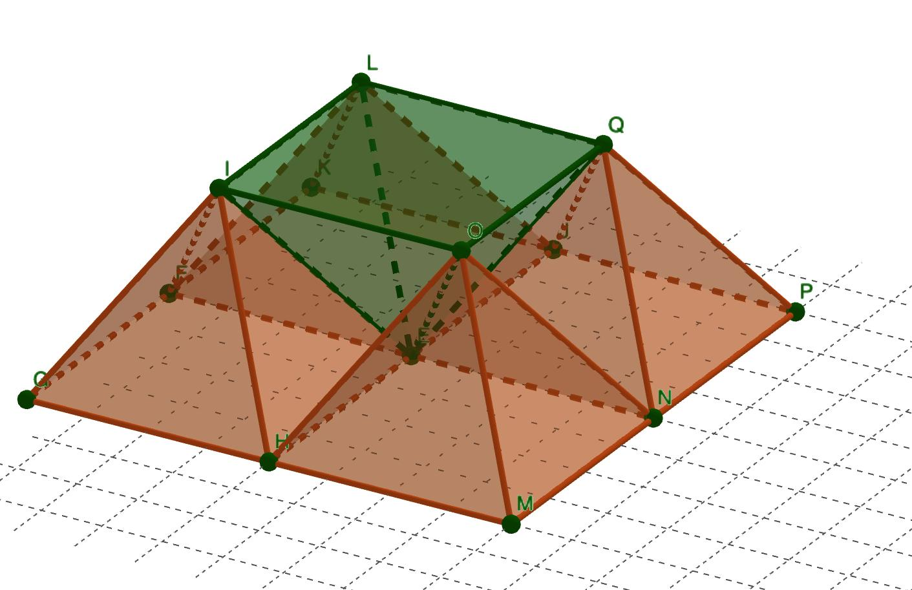

Sphere-Based Multi-Component Composite Solids
# Source: AI Source: Provided by: [Data Path: Persons Table -> ID Column: 1, Name_En Column: Motasem Essam] -> From: [ChatGPT] on [7/25/2026]
Formed by combining three or more spherical components.
Examples:
- Multiple spheres arranged in a linear pattern.
- Spheres clustered around a central sphere.
- Different-sized spheres connected to other solids.
- Spherical components arranged symmetrically.
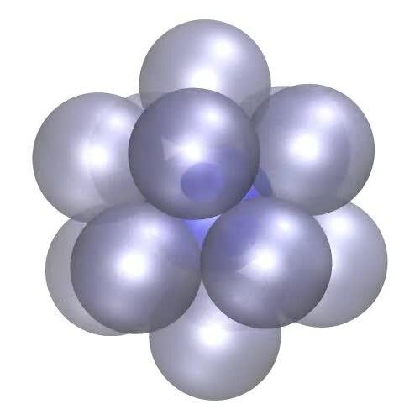

Hemisphere-Based Multi-Component Composite Solids
# Source: AI Source: Provided by: [Data Path: Persons Table -> ID Column: 1, Name_En Column: Motasem Essam] -> From: [ChatGPT] on [7/25/2026]
Formed by combining three or more hemispherical components.
Examples:
- Multiple hemispheres arranged in layers.
- Hemispheres joined base-to-base.
- Several hemispheres attached to cylindrical components.
- Repeated hemispherical components arranged in groups.
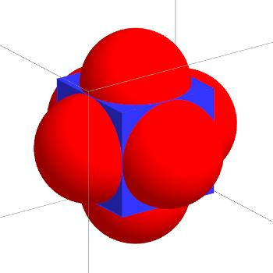

Mixed-Shape Multi-Component Composite Solids
# Source: AI Source: Provided by: [Data Path: Persons Table -> ID Column: 1, Name_En Column: Motasem Essam] -> From: [ChatGPT] on [7/25/2026]
Formed by combining three or more different types of solid components.
Examples:
- Rectangular prism, cylinder, and cone.
- Sphere, cylinder, and hemisphere.
- Prism, pyramid, and cylinder.
- Multiple prisms, cylinders, cones, and spherical components.


Classification by Component Arrangement
# Source: AI Source: Provided by: [Data Path: Persons Table -> ID Column: 1, Name_En Column: Motasem Essam] -> From: [ChatGPT] on [7/25/2026]
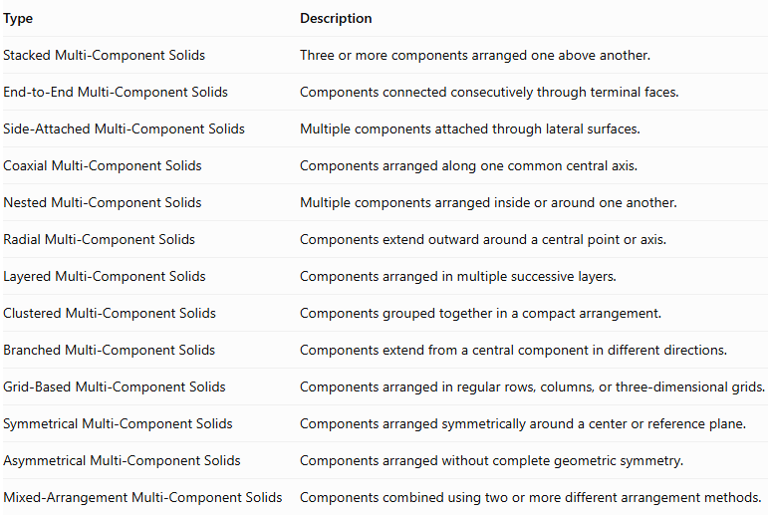
Type | Description
Stacked Multi-Component Solids | Three or more components arranged one above another.
End-to-End Multi-Component Solids | Components connected consecutively through terminal faces.
Side-Attached Multi-Component Solids | Multiple components attached through lateral surfaces.
Coaxial Multi-Component Solids | Components arranged along one common central axis.
Nested Multi-Component Solids | Multiple components arranged inside or around one another.
Radial Multi-Component Solids | Components extend outward around a central point or axis.
Layered Multi-Component Solids | Components arranged in multiple successive layers.
Clustered Multi-Component Solids | Components grouped together in a compact arrangement.
Branched Multi-Component Solids | Components extend from a central component in different directions.
Grid-Based Multi-Component Solids | Components arranged in regular rows, columns, or three-dimensional grids.
Symmetrical Multi-Component Solids | Components arranged symmetrically around a center or reference plane.
Asymmetrical Multi-Component Solids | Components arranged without complete geometric symmetry.
Mixed-Arrangement Multi-Component Solids | Components combined using two or more different arrangement methods.
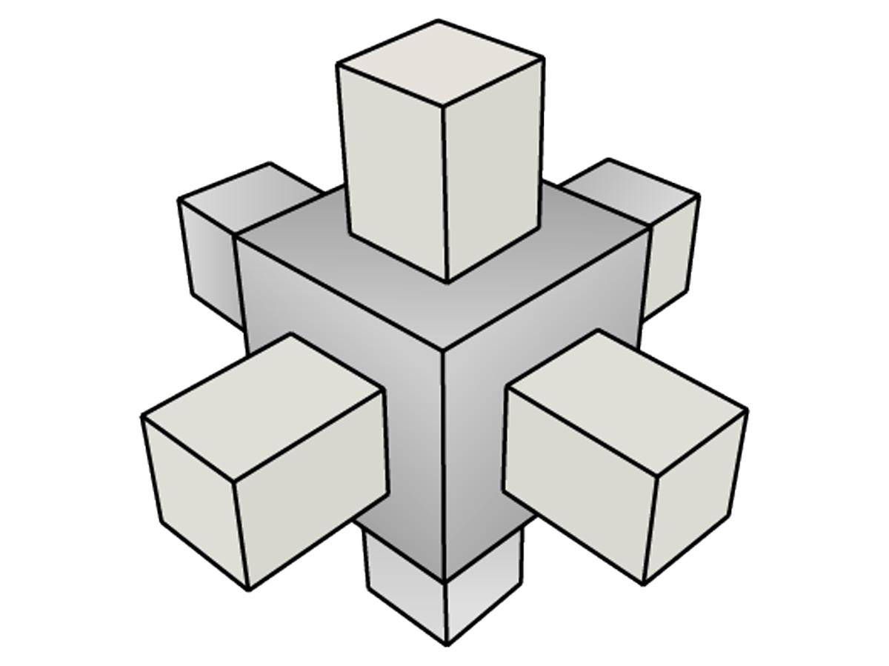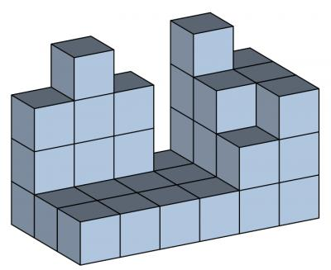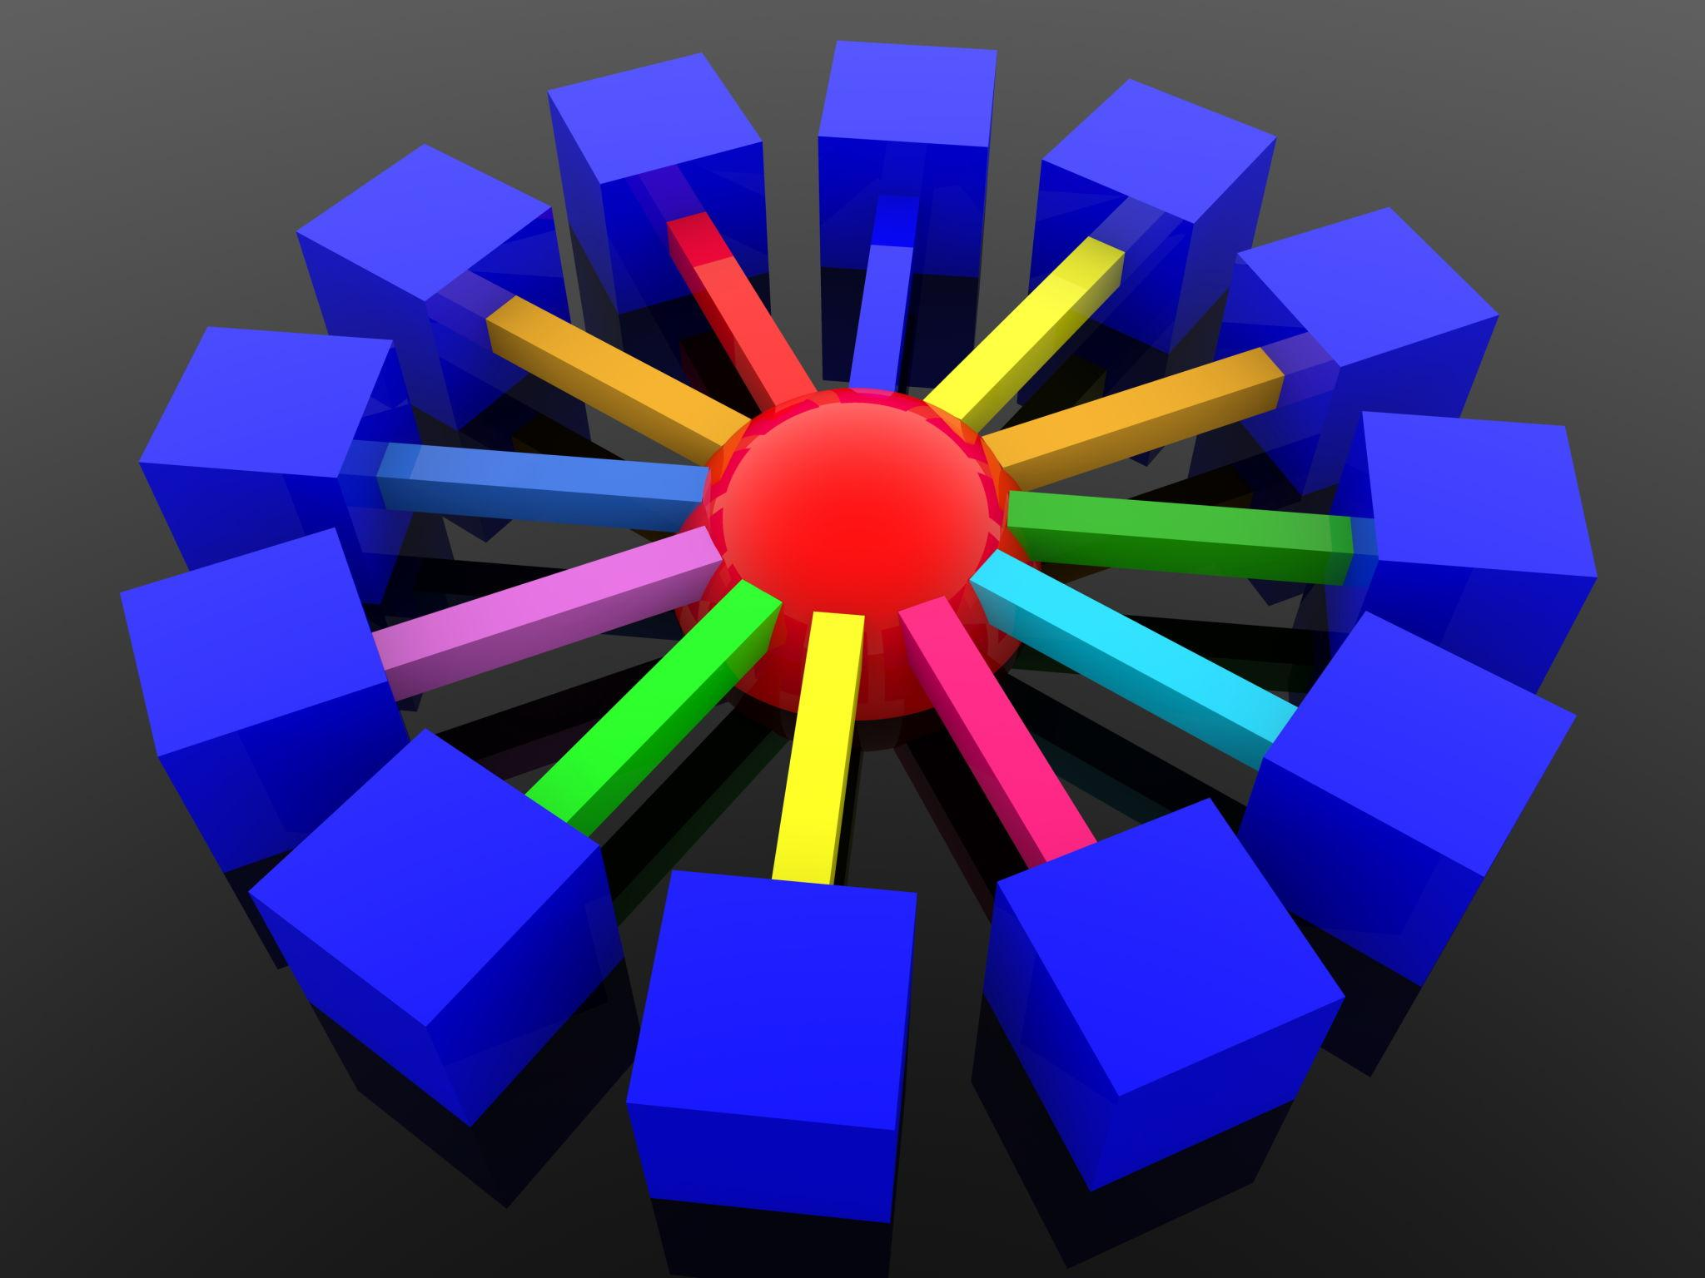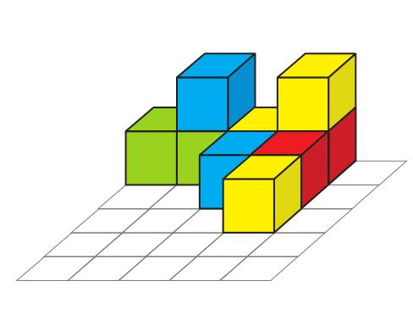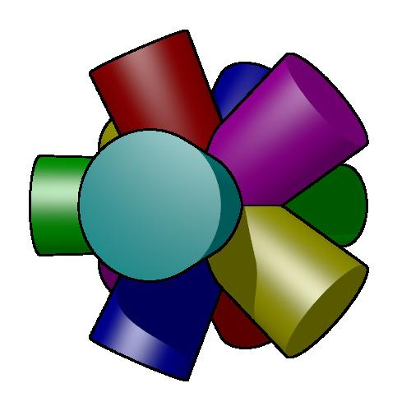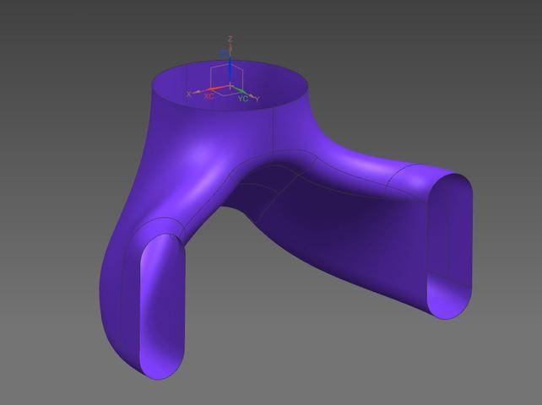

Classification by Number of Components
# Source: AI Source: Provided by: [Data Path: Persons Table -> ID Column: 1, Name_En Column: Motasem Essam] -> From: [ChatGPT] on [7/25/2026]
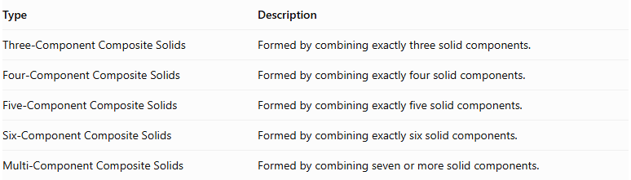
Type | Description
Three-Component Composite Solids | Formed by combining exactly three solid components.
Four-Component Composite Solids | Formed by combining exactly four solid components.
Five-Component Composite Solids | Formed by combining exactly five solid components.
Six-Component Composite Solids | Formed by combining exactly six solid components.
Multi-Component Composite Solids | Formed by combining seven or more solid components.
Note: Multi-component composite solids is the general category for structures containing three or more components. The subdivisions above classify them by their exact component count or count range.

Classification by Component Similarity
# Source: AI Source: Provided by: [Data Path: Persons Table -> ID Column: 1, Name_En Column: Motasem Essam] -> From: [ChatGPT] on [7/25/2026]
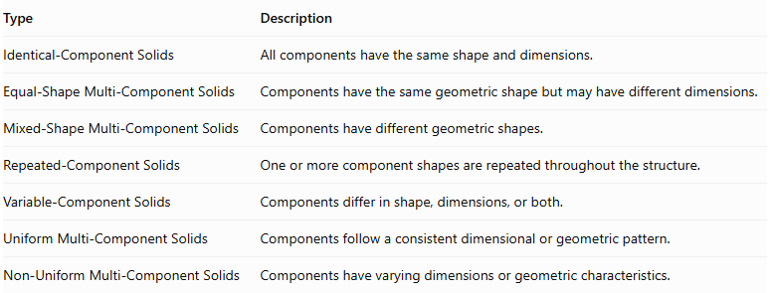
Type | Description
Identical-Component Solids | All components have the same shape and dimensions.
Equal-Shape Multi-Component Solids | Components have the same geometric shape but may have different dimensions.
Mixed-Shape Multi-Component Solids | Components have different geometric shapes.
Repeated-Component Solids | One or more component shapes are repeated throughout the structure.
Variable-Component Solids | Components differ in shape, dimensions, or both.
Uniform Multi-Component Solids | Components follow a consistent dimensional or geometric pattern.
Non-Uniform Multi-Component Solids | Components have varying dimensions or geometric characteristics.

Mathematical Properties and Formulas
# Source: AI Source: Provided by: [Data Path: Persons Table -> ID Column: 1, Name_En Column: Motasem Essam] -> From: [ChatGPT] on [7/25/2026]
The mathematical properties depend on the number, shape, dimensions, and arrangement of the components.

Volume
# Source: AI Source: Provided by: [Data Path: Persons Table -> ID Column: 1, Name_En Column: Motasem Essam] -> From: [ChatGPT] on [7/25/2026]
For components that do not overlap internally:
$$V_{total}=\sum_{i=1}^{n}{V_{i}}$$
Where:
- $V_{total}$ = Total volume.
- $V_{i}$ = Volume of each component.
- $n$ = Number of components.
For components with overlapping interiors, the overlapping regions must be subtracted so that each occupied region is counted only once.
For three components:
$$V_{total}=V_{1}+V_{2}+V_{3}-V_{12}-V_{13}-V_{23}+V_{123}$$
Where:
- $V_{12}$, $V_{13}$, $V_{23}$ = Pairwise overlap volumes.
- $V_{123}$ = Volume shared by all three components.

External Surface Area
# Source: AI Source: Provided by: [Data Path: Persons Table -> ID Column: 1, Name_En Column: Motasem Essam] -> From: [ChatGPT] on [7/25/2026]
The external surface area includes only the surfaces exposed to the outside.
For multiple components:
$${SA}_{total}=\sum_{i=1}^{n}{{SA}_{i}}-A_{hidden}$$
Here, $A_{hidden}$ represents the total surface-area contribution of all hidden component surfaces.
For complete matching planar interfaces, each interface hides two corresponding surface regions. Therefore, subtract twice the contact area for each such interface.
For curved, partial, or intersecting attachments, the exposed surfaces must be calculated from the actual geometry.

Overall Dimensions
# Source: AI Source: Provided by: [Data Path: Persons Table -> ID Column: 1, Name_En Column: Motasem Essam] -> From: [ChatGPT] on [7/25/2026]
For components arranged consecutively along a common direction:
$$L_{total}=\sum_{i=1}^{n}{L_{i}}$$
For vertically stacked components:
$$H_{total}=\sum_{i=1}^{n}{H_{i}}$$
These formulas apply when components are arranged consecutively without overlapping along the measured direction.

Common Component Volume Formulas
# Source: AI Source: Provided by: [Data Path: Persons Table -> ID Column: 1, Name_En Column: Motasem Essam] -> From: [ChatGPT] on [7/25/2026]
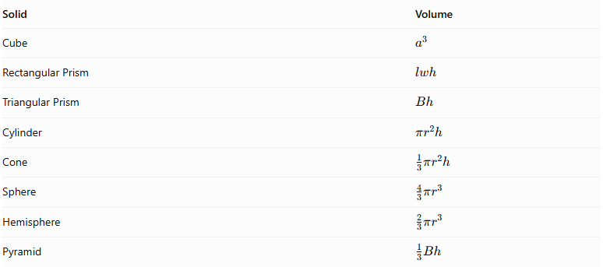
Solid | Volume
Cube | $$a^{3}$$
Rectangular Prism | $$lwh$$
Triangular Prism | $$Bh$$
Cylinder | $$πr^{2}h$$
Cone | $$\frac{1}{3}πr^{2}h$$
Sphere | $$\frac{4}{3}πr^{3}$$
Hemisphere | $$\frac{2}{3}πr^{3}$$
Pyramid | $$\frac{1}{3}Bh$$

Worked Examples

Example 1: Three Rectangular Prisms Stacked Vertically
# Source: AI Source: Provided by: [Data Path: Persons Table -> ID Column: 1, Name_En Column: Motasem Essam] -> From: [ChatGPT] on [7/25/2026]
Three rectangular prisms are stacked vertically to form one multi-component composite solid.
Each prism has:
- Length = 6 cm
- Width = 4 cm
- Height = 3 cm
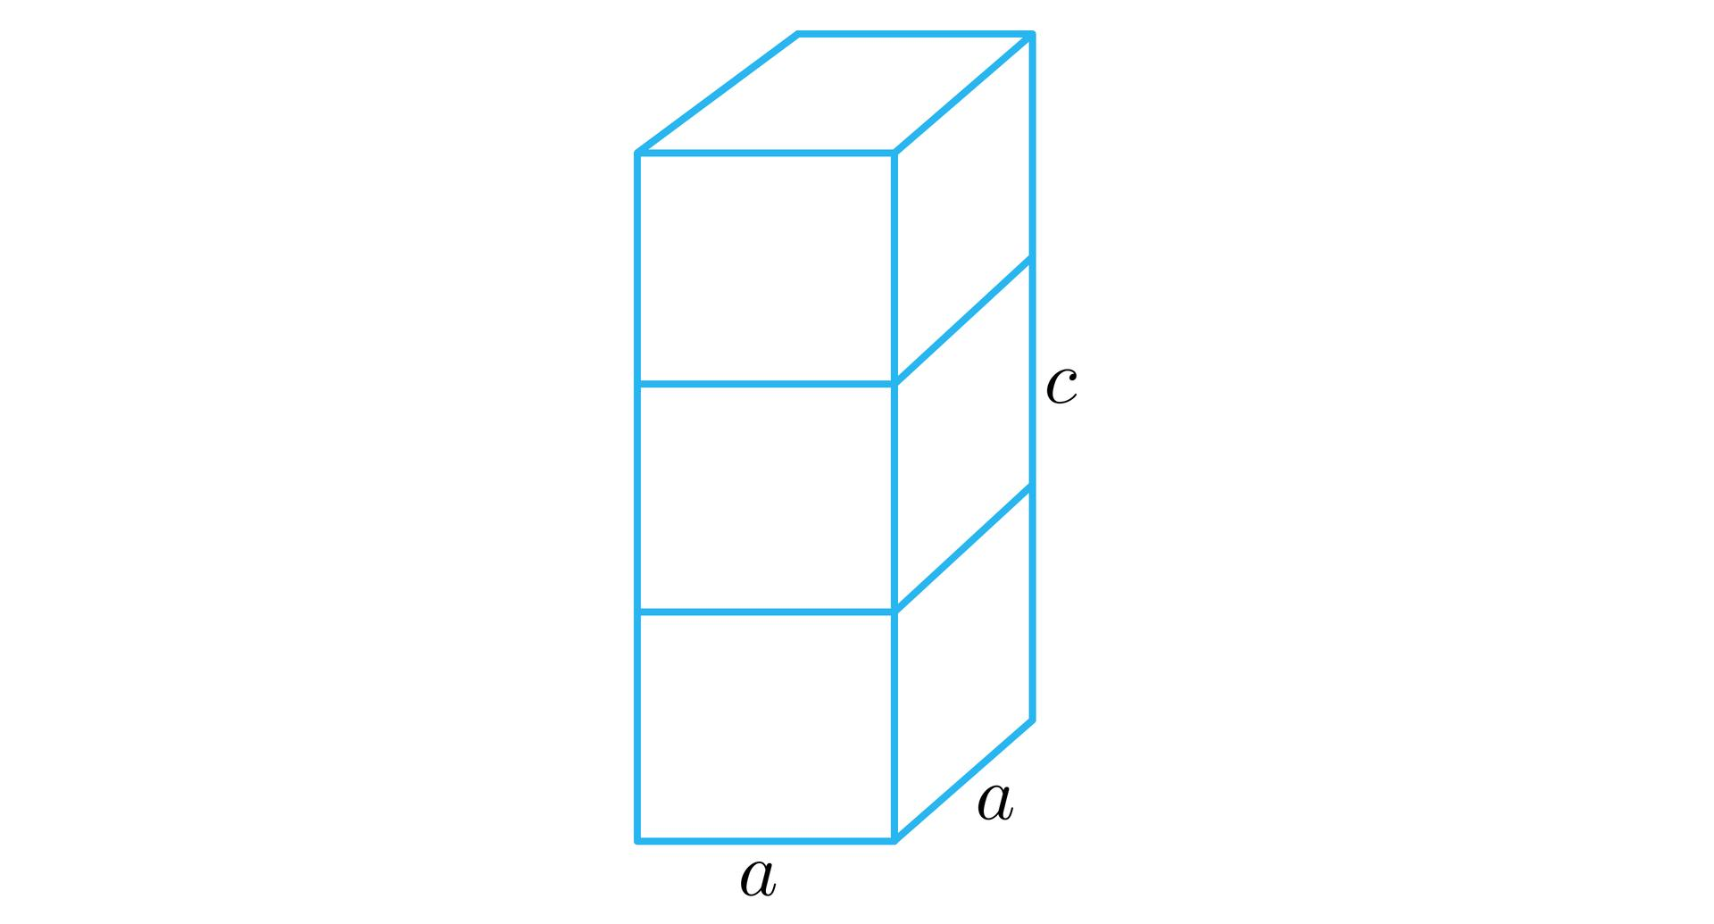
Step 1: Calculate the volume of one prism.
$$V_{1}=lwh$$
$$V_{1}=6×4×3$$
$$V_{1}=72{ cm}^{3}$$
Step 2: Calculate the total volume.
$$V_{total}=3×72$$
$$\boxed{V_{total}=216{ cm}^{3}}$$
Step 3: Calculate the overall height.
$$H=3+3+3$$
$$\boxed{H=9 cm}$$
Step 4: Calculate the external surface area.
The resulting solid is a rectangular prism with dimensions:
$$6×4×9$$
$$SA=2(lw+lh+wh)$$
$$SA=2(24+54+36)$$
$$\boxed{SA=228{ cm}^{2}}$$

Example 2: A Hemisphere, Cylinder, and Cone Combined Coaxially
# Source: AI Source: Provided by: [Data Path: Persons Table -> ID Column: 1, Name_En Column: Motasem Essam] -> From: [ChatGPT] on [7/25/2026]
Three different components are arranged vertically along a common axis:
- Hemisphere: radius = 3 cm.
- Cylinder: radius = 3 cm, height = 6 cm.
- Cone: radius = 3 cm, height = 4 cm.
Their circular bases are connected, creating one multi-component composite solid.
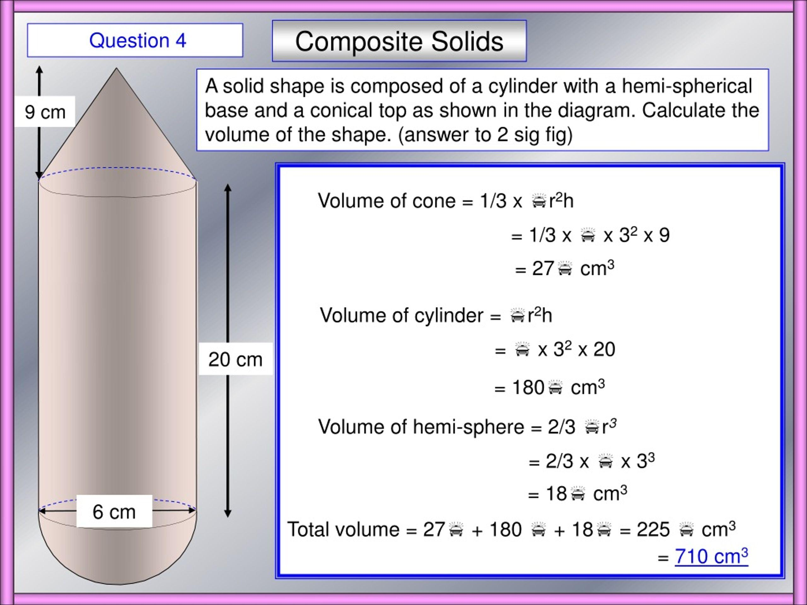
Step 1: Calculate the hemisphere volume.
$$V_{h}=\frac{2}{3}πr^{3}$$
$$V_{h}=\frac{2}{3}π(3)^{3}=18π$$
Step 2: Calculate the cylinder volume.
$$V_{c}=πr^{2}h$$
$$V_{c}=π(3)^{2}(6)=54π$$
Step 3: Calculate the cone volume.
$$V_{k}=\frac{1}{3}πr^{2}h$$
$$V_{k}=\frac{1}{3}π(3)^{2}(4)=12π$$
Step 4: Calculate the total volume.
$$V_{total}=18π+54π+12π$$
$$\boxed{V_{total}=84π≈263.89{ cm}^{3}}$$
Step 5: Calculate the external surface area.
The exposed surfaces are:
- Hemisphere curved surface.
- Cylinder curved surface.
- Cone curved surface.
The hemisphere curved surface area is:
$${SA}_{h}=2πr^{2}=18π$$
The cylinder curved surface area is:
$${SA}_{c}=2πrh=36π$$
The cone slant height is:
$$l=\sqrt{r^{2}+h^{2}}$$
$$l=\sqrt{3^{2}+4^{2}}=5$$
The cone curved surface area is:
$${SA}_{k}=πrl=15π$$
Therefore:
$${SA}_{total}=18π+36π+15π$$
$$\boxed{{SA}_{total}=69π≈216.77{ cm}^{2}}$$
Step 6: Calculate the overall height.
$$H=3+6+4$$
$$\boxed{H=13 cm}$$

Important Characteristics
# Source: AI Source: Provided by: [Data Path: Persons Table -> ID Column: 1, Name_En Column: Motasem Essam] -> From: [ChatGPT] on [7/25/2026]
- They contain at least three solid components.
- Components may have identical or different geometric shapes.
- Components can be arranged using multiple connection methods.
- They may contain repeated or mixed-shape components.
- Their arrangement can be regular, irregular, symmetrical, or asymmetrical.
- Their volume depends on the individual component volumes and any overlapping regions.
- Their external surface area includes only exposed surfaces.
- Their overall dimensions depend on the relative positions and orientations of all components.
- They can form simple structures or highly complex three-dimensional assemblies.

Comparison with Other Composite Solid Arrangements
# Source: AI Source: Provided by: [Data Path: Persons Table -> ID Column: 1, Name_En Column: Motasem Essam] -> From: [ChatGPT] on [7/25/2026]
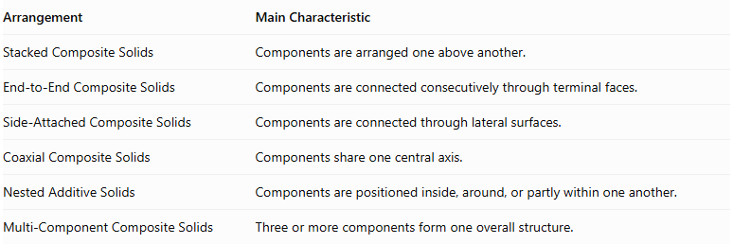
Arrangement | Main Characteristic
Stacked Composite Solids | Components are arranged one above another.
End-to-End Composite Solids | Components are connected consecutively through terminal faces.
Side-Attached Composite Solids | Components are connected through lateral surfaces.
Coaxial Composite Solids | Components share one central axis.
Nested Additive Solids | Components are positioned inside, around, or partly within one another.
Multi-Component Composite Solids | Three or more components form one overall structure.
Important distinction: Multi-component composite solids are classified by the number of components, whereas stacked, end-to-end, side-attached, coaxial, and nested solids are classified by their arrangement. A multi-component solid can therefore belong to several arrangement categories simultaneously.

Applications
# Source: AI Source: Provided by: [Data Path: Persons Table -> ID Column: 1, Name_En Column: Motasem Essam] -> From: [ChatGPT] on [7/25/2026]
Multi-component composite solids are commonly used to represent:
- Complex architectural structures.
- Mechanical assemblies and machine components.
- Industrial equipment.
- Multi-section pipes and connecting systems.
- Storage structures and tanks.
- Furniture and structural frameworks.
- Three-dimensional CAD models.
- Engineering and manufacturing components.

Key Points
# Source: AI Source: Provided by: [Data Path: Persons Table -> ID Column: 1, Name_En Column: Motasem Essam] -> From: [ChatGPT] on [7/25/2026]
- Multi-component composite solids contain three or more solid components.
- They may consist of identical, equal-shaped, or mixed-shaped components.
- Their components can be stacked, attached, nested, coaxial, radial, or clustered.
- Their volume is calculated by combining component volumes and correcting for overlaps.
- Their external surface area includes only exposed surfaces.
- Their overall dimensions depend on the arrangement of all components.
- They can combine multiple arrangement methods in one structure.

Conclusion
# Source: AI Source: Provided by: [Data Path: Persons Table -> ID Column: 1, Name_En Column: Motasem Essam] -> From: [ChatGPT] on [7/25/2026]
Multi-Component Composite Solids are three-dimensional structures formed by combining three or more solid geometric components into one overall object. They may contain identical or different solid shapes and can follow various arrangements, including stacking, end-to-end connection, side attachment, coaxial alignment, nesting, and radial distribution. Their defining characteristic is the presence of multiple components, making them useful for representing complex geometric structures and real-world assemblies.

